Name: Moses Muamba-Nzambi & Justin Albecker
Course: CST-350
Assignment: Milestone 3
Date: July 12, 2026
Instructor: Abhishek Jain

Screencast -
Github - https://github.com/MosesMNZ/CST-350-Milestone-3

CST-350 Milestone 3 - Minesweeper User Interface
Student: Moses Muamba-Nzambi

Introduction
For Milestone 3, we continued developing our ASP.NET Core MVC Minesweeper application by adding AJAX and Partial Views. Instead of refreshing the entire page after every move, only the selected game cell is updated, creating a smoother user experience. We also implemented a timer that updates dynamically and added right-click functionality so players can place or remove flags. This milestone builds on the ButtonGrid and Partial Views activities completed earlier in CST-350.

Application Screenshots:

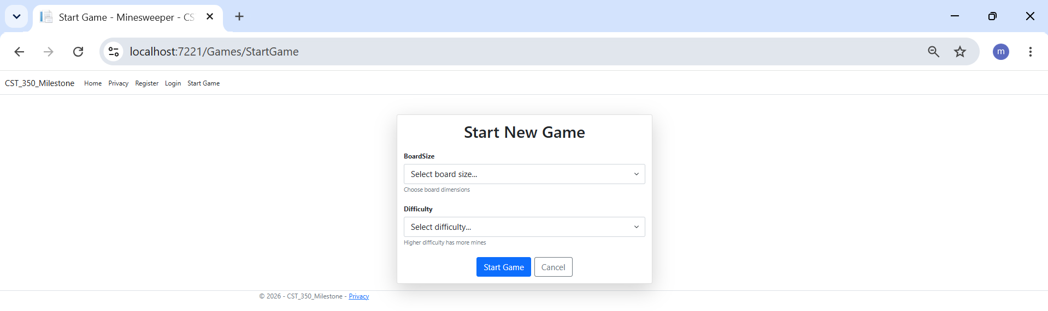Figure 1. Start Game page where the player selects the board size and difficulty before starting a new Minesweeper game.

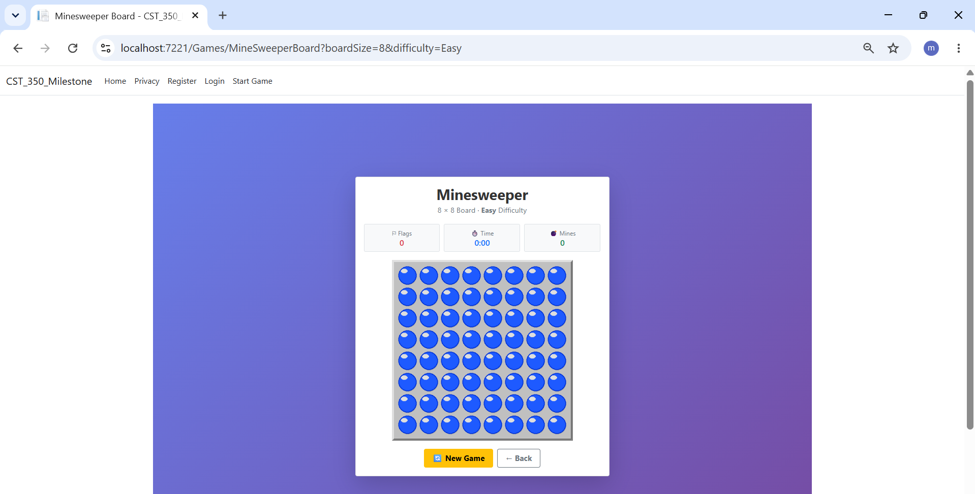Figure 2. The MineSweeper game board displayed after the player starts a new game. The board is generated dynamically based on the selected board size.

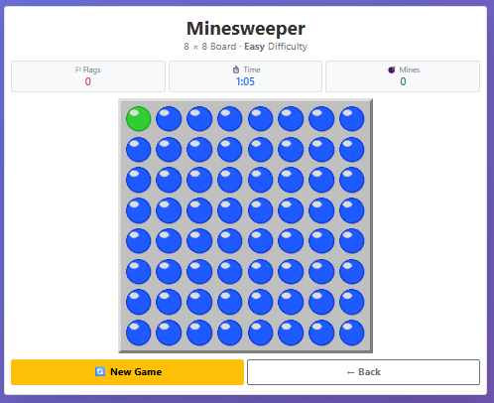
Figure 3. A single game cell is updated after being selected. AJAX refreshes only the affected cell instead of reloading the entire page.
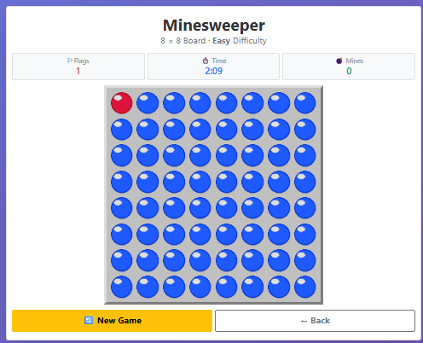
Figure 4. A flag is placed on a game cell using the right-click functionality. Players can also right-click again to remove the flag.

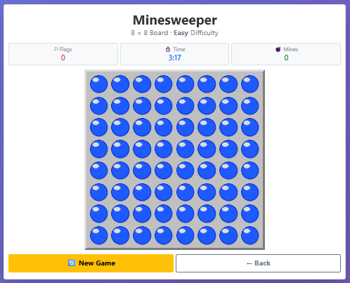
Figure 5. The game timer updates automatically using AJAX without refreshing the page.

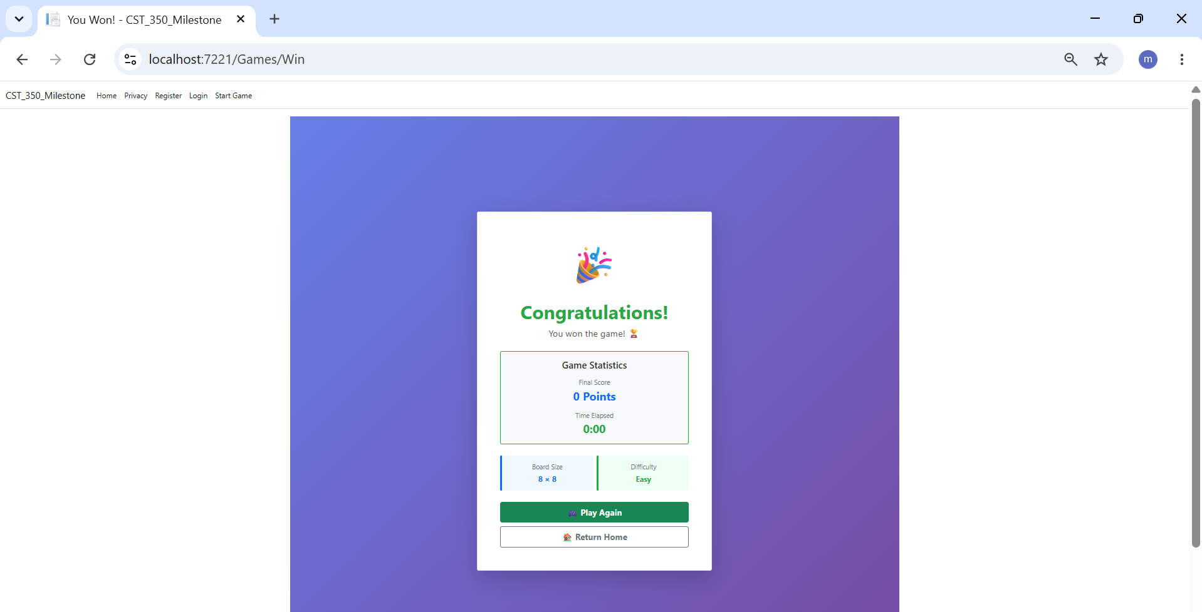Figure 6. The game outcome page displayed after the player wins the game.

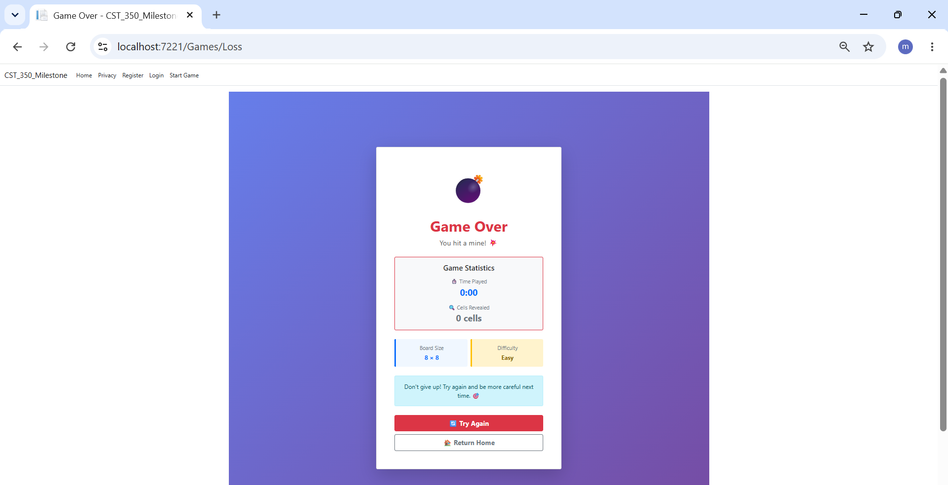
Figure 6. The game outcome page displayed after the player loses the game.

Implementation
The application continues to follow the ASP.NET Core MVC design pattern used throughout the CST-350 activities. Models store the application data, Views display the user interface, and Controllers process user requests.
The MineSweeper board is displayed using Partial Views. This allows only the selected cell to be updated after each move instead of refreshing the entire page, similar to the Partial Views activity completed during the course.
AJAX was implemented with jQuery to communicate with the controller asynchronously. When a player clicks a cell, an AJAX request is sent to the controller, which processes the request and returns an updated Partial View. This allows the browser to refresh only the affected cell.
Right-click functionality was added using JavaScript and jQuery. Players can place or remove flags without reloading the page, and flagged cells do not respond to left-click events until the flag is removed.
The game timer was updated to refresh dynamically using AJAX without requiring a full page reload. This demonstrates asynchronous communication between the browser and the server while providing real-time feedback to the player.
This milestone enhanced the frontend by using AJAX, Partial Views, and jQuery to provide a more responsive user experience without requiring a full page refresh. These improvements build on the MVC concepts introduced throughout the CST-350 activities.

Summary of Key Concepts
This milestone introduced several important web development concepts. Partial Views allow only part of a page to be updated, improving performance and reducing unnecessary page refreshes. AJAX enables asynchronous communication between the browser and the server, while jQuery simplifies event handling and AJAX requests. The project also continues to use the MVC design pattern by separating Models, Views, and Controllers into different responsibilities. Together, these concepts create a more responsive and interactive web application.

